**Indira College of Engineering and Management Pune**



# DOCTOR APPOINTMENT SYSTEM

Project Submit By -

**Nainesh Gopalrao Iche - 81107**

Under the Guidance of -

**Dr. Darshana Desai Mam**

## **Table of Contents**

1 Introduction

* 1. Introduction
  2. Objective
  3. Needs of Online Doctor Appointment
  4. Tools and Technique

1.4.1 External Interfaces

2 Task and Activities Performed

* 1. Profile of Problems
  2. Structure of the project
  3. Scope and Feasibility
  4. System Analysis
  5. System Design
  6. Implementation
  7. Test Generation

Screen Shot

## **1. Introduction**

# Introduction

Online Doctor Appointment system is the system where the users can search the doctors that the needed for and also can take appointment. This system will make easy for the doctors and patients to see their list of doctors and their patients. Find & book appointments with doctors, diagnostic tests, clinics, hospitals.

Users can even give their feedback to the system administration. Admin can manage doctors, patients. Administration have full authority to add, delete and update doctors and patients. They even add Medical colleges and medical doctors.

# Objective

The main objective is to develop the software that covers all therapists of management and operations of clinics. It enables healthcare providers to improve operational effectiveness, reduce costs, reduce medical errors, reduce time consumption and enhance delivery of quality of care.

# Needs of Online Doctor Appointment

Helps patients to get the doctors appointment’s any time. Provides a user interactive search that provides you diverse options in terms of specialty, locality and doctors. It make the best medical care available to you in the simplest form. It helps you save time of interacting with the doctors in a manual fashion and makes the same possible with diverse set of options available in the application. It services available 24/7 and can help you get in touch with the doctors directly. We help patients to book appointments from anywhere and from any device.

# Tools and Technique

1. Php
2. Xampp
3. Mysql
4. HTML
5. Css

Php

**Hypertext Preprocessor** (or simply **PHP**) is a [server-side scripting](https://en.wikipedia.org/wiki/Server-side_scripting) language designed for [Web](https://en.wikipedia.org/wiki/Web_development) [development,](https://en.wikipedia.org/wiki/Web_development) but also used as a [general-purpose programming language.](https://en.wikipedia.org/wiki/General-purpose_programming_language) It was originally created

by [Rasmus Lerdorf](https://en.wikipedia.org/wiki/Rasmus_Lerdorf) in 1994[,]](https://en.wikipedia.org/wiki/PHP#cite_note-History_of_PHP-5) the PHP [reference implementation](https://en.wikipedia.org/wiki/Reference_implementation) is now produced *by* The PHP Group. PHP originally stood for Personal *Home Page*[,]](https://en.wikipedia.org/wiki/PHP#cite_note-History_of_PHP-5) but it now stands for the [recursive acronym](https://en.wikipedia.org/wiki/Recursive_acronym) *PHP: Hypertext Preprocessor*.

PHP code may be embedded into [HTML](https://en.wikipedia.org/wiki/HTML) code, or it can be used in combination with various [web](https://en.wikipedia.org/wiki/Web_template_system) [template systems,](https://en.wikipedia.org/wiki/Web_template_system) web content management systems, and [web frameworks](https://en.wikipedia.org/wiki/Web_framework). PHP code is usually processed by a PHP [interpreter](https://en.wikipedia.org/wiki/Interpreter_(computing)) implemented as a [module](https://en.wikipedia.org/wiki/Plugin_(computing)) in the web server or as a [Common Gateway](https://en.wikipedia.org/wiki/Common_Gateway_Interface) [Interface](https://en.wikipedia.org/wiki/Common_Gateway_Interface) (CGI) executable. The web server combines the results of the interpreted and executed PHP code, which may be any type of data, including images, with the generated web page. PHP code may also be executed with a [command-line interface](https://en.wikipedia.org/wiki/Command-line_interface) (CLI) and can be used to

implement [standalone](https://en.wikipedia.org/wiki/Computer_software) [graphical applications](https://en.wikipedia.org/wiki/Graphical_user_interface)

Xampp

XAMPP is a [free and open source](https://en.wikipedia.org/wiki/Free_software) [cross-platform](https://en.wikipedia.org/wiki/Cross-platform) [web server](https://en.wikipedia.org/wiki/Web_server) [solution stack](https://en.wikipedia.org/wiki/Solution_stack) package developed by Apache Friends, consisting mainly of the [Apache HTTP Server,](https://en.wikipedia.org/wiki/Apache_HTTP_Server) [MariaDB](https://en.wikipedia.org/wiki/MariaDB) [database](https://en.wikipedia.org/wiki/Database), and [interpreters](https://en.wikipedia.org/wiki/Interpreter_(computing)) for scripts written in the [PHP](https://en.wikipedia.org/wiki/PHP) and [Perl](https://en.wikipedia.org/wiki/Perl) [programming languages](https://en.wikipedia.org/wiki/Programming_language). XAMPP stands for Cross-Platform (X), Apache (A), MariaDB (M), PHP (P) and Perl (P). It is a simple, lightweight Apache distribution that makes it extremely easy for developers to create a local web server for testing and deployment purposes. Everything needed to set up a web server – server application (Apache), database (MariaDB), and scripting language (PHP) – is included in an extractable file. XAMPP is also cross-platform, which means it works equally well on Linux, Mac and Windows. Since most actual web server deployments use the same components as XAMPP, it makes transitioning from a local test server to a live server extremely easy as well.

Mysql

MySQL Workbench is a unified visual tool for database architects, developers, and DBAs. MySQL Workbench provides data modeling, SQL development, and comprehensive administration tools for server configuration, user administration, backup, and much more. MySQL Workbench is available on Windows, Linux and Mac OS X.

HTML

Hypertext Markup Language (HTML) is the standard [markup language](https://en.wikipedia.org/wiki/Markup_language) for creating [web pages](https://en.wikipedia.org/wiki/Web_page) and [web](https://en.wikipedia.org/wiki/Web_application) [applications.](https://en.wikipedia.org/wiki/Web_application) With [Cascading Style Sheets](https://en.wikipedia.org/wiki/Cascading_Style_Sheets) (CSS) and [JavaScript](https://en.wikipedia.org/wiki/JavaScript), it forms a triad of cornerstone technologies for the [World Wide Web](https://en.wikipedia.org/wiki/World_Wide_Web)[.[4]](https://en.wikipedia.org/wiki/HTML#cite_note-4)

[Web browsers](https://en.wikipedia.org/wiki/Web_browser) receive HTML documents from a [web server](https://en.wikipedia.org/wiki/Web_server) or from local storage and [render](https://en.wikipedia.org/wiki/Browser_engine) the documents into multimedia web pages. HTML describes the structure of a web page [semantically](https://en.wikipedia.org/wiki/Semantic_Web) and originally included cues for the appearance of the document.

[HTML elements](https://en.wikipedia.org/wiki/HTML_element) are the building blocks of HTML pages. With HTML constructs, [images](https://en.wikipedia.org/wiki/HTML_element#Images_and_objects) and other objects such as [interactive forms](https://en.wikipedia.org/wiki/Fieldset) may be embedded into the rendered page. HTML provides a means to

create [structured documents](https://en.wikipedia.org/wiki/Structured_document) by denoting structural [semantics](https://en.wikipedia.org/wiki/Semantics) for text such as headings, paragraphs, lists, [links,](https://en.wikipedia.org/wiki/Hyperlink) quotes and other items.

Bootstrap

Bootstrap is a [free and open-source](https://en.wikipedia.org/wiki/Free_and_open-source_software) front-end framework for designing [websites](https://en.wikipedia.org/wiki/Website) and [web applications](https://en.wikipedia.org/wiki/Web_application). It contains [HTML](https://en.wikipedia.org/wiki/HTML)- and [CSS](https://en.wikipedia.org/wiki/CSS)-based design templates for [typography](https://en.wikipedia.org/wiki/Typography), forms, buttons, navigation and other interface components, as well as optional [JavaScript](https://en.wikipedia.org/wiki/JavaScript) extensions. Unlike many web frameworks, it concerns itself with [front-end development](https://en.wikipedia.org/wiki/Front-end_web_development) only.

Css

Cascading Style Sheets (CSS) is a [style sheet language](https://en.wikipedia.org/wiki/Style_sheet_language) used for describing the [presentation](https://en.wikipedia.org/wiki/Presentation_semantics) of a document written in a [markup language](https://en.wikipedia.org/wiki/Markup_language) like [HTML.](https://en.wikipedia.org/wiki/HTML) CSS is a cornerstone technology of the [World Wide](https://en.wikipedia.org/wiki/World_Wide_Web) [Web,](https://en.wikipedia.org/wiki/World_Wide_Web) alongside HTML and [JavaScript.](https://en.wikipedia.org/wiki/JavaScript)

CSS is designed to enable the separation of presentation and content, including [layout](https://en.wikipedia.org/wiki/Page_layout), [colors](https://en.wikipedia.org/wiki/Color),

and [fonts.](https://en.wikipedia.org/wiki/Typeface) This separation can improve content [accessibility,](https://en.wikipedia.org/wiki/Accessibility) provide more flexibility and control in the specification of presentation characteristics, enable multiple [web pages](https://en.wikipedia.org/wiki/Web_page) to share formatting by specifying the relevant CSS in a separate css file, and reduce complexity and repetition in the structural content.

# Specification Requirement

## **External Interfaces**

- This interface will be actual interface through which the user will communication with the application and perform the desired tasks.

Admin login

### D:

**Role**: Admin wishes to login to the system

**Precondition**: Username and Password

**Success end Condition**: Main option of screen display

**Failed end Condition**: User has entered incorrect Username and Password or both

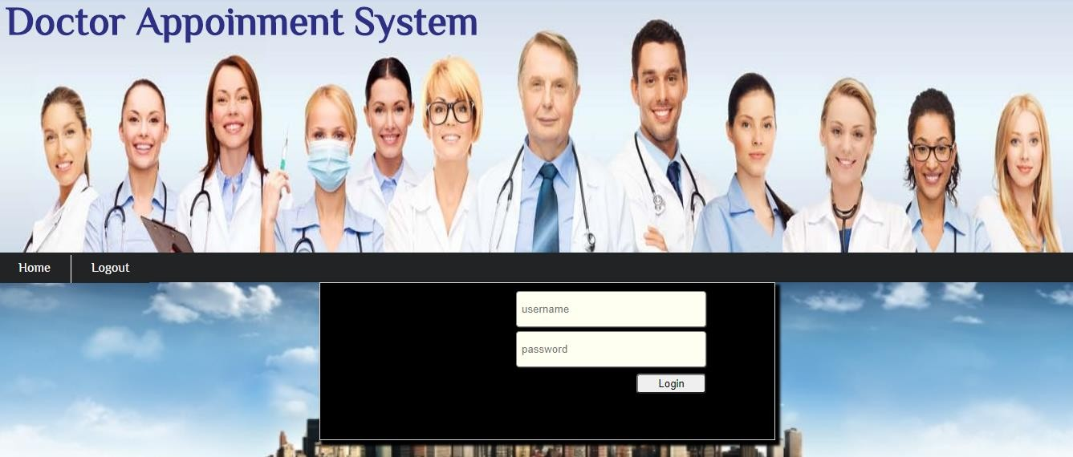

**After Login:**

### ID:

**Precondition:** User has successfully navigated to the search result

**Success end Condition:** User has successfully made the changes

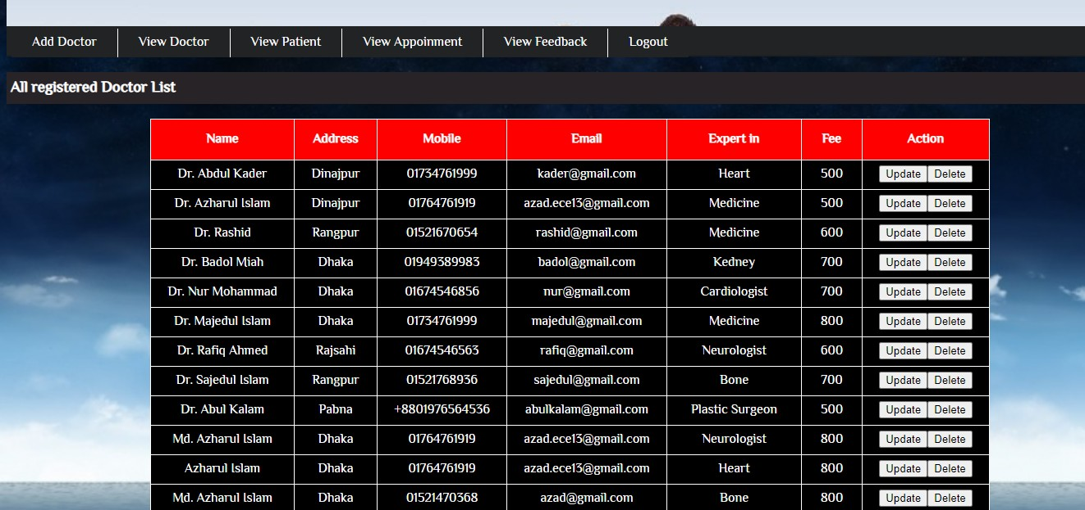

* + - * 1. To edit user records in the data base, first search the record you want to edit then click on ‘edit’ button.
        2. Edit the particulars user that you want to change and click on’ Save’ button.
    1. **Software Product Features** Online Doctors Appointment Login Information System
* Description

-The system will maintain the login information of its user to enter in to the software

* Validating Checks

-Administrator need to login the unique id and password.

-Contact number should have maximum 10 digits.

-All the details must be fill up.

-Email address should be in the proper format.

* Sequencing information

-Login information should be filled before the user allowed.

* Error Handling

-If user doesn’t filled up validate information then the system display error message for user and request to enter the validate information.

Performance required

* Security

-System should be Protected from unauthorized access Where the validate Username and Password are required so no other can access.

* Maintainability

-System should be design in a maintain order. So it can be easily modified.

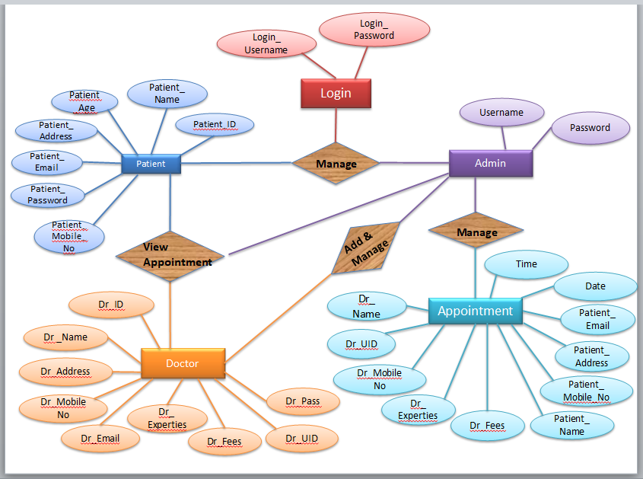

**Figure: ER diagram**

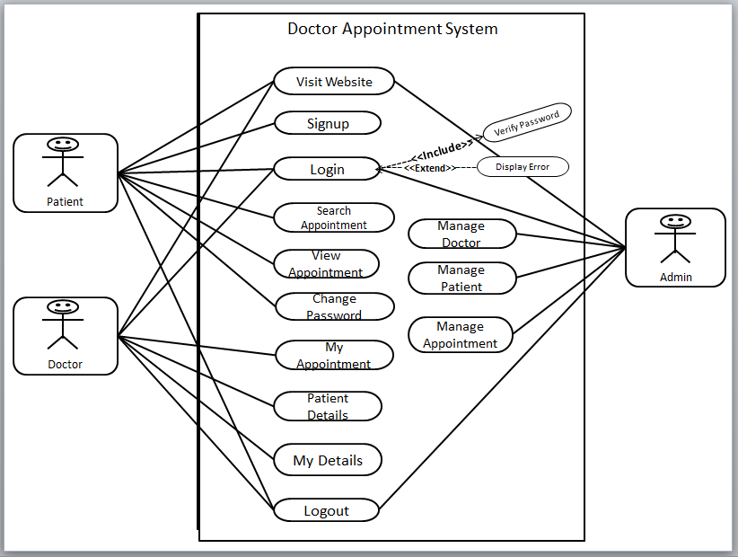

**Figure: Use case Diagram**

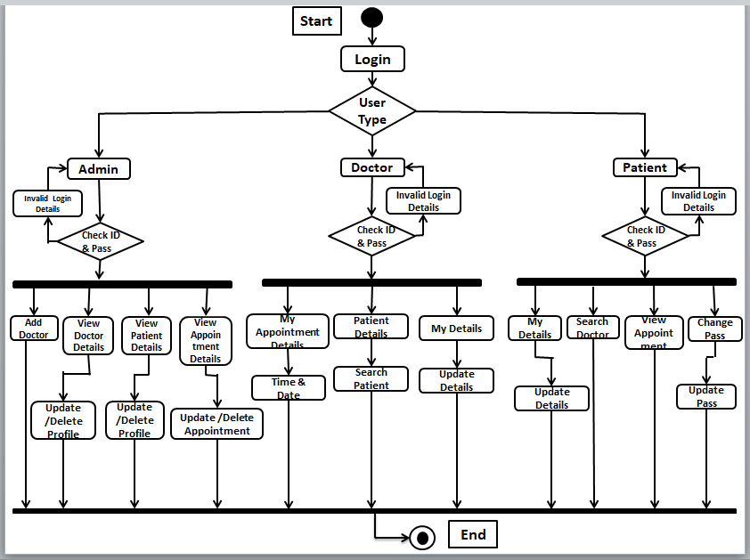

**Figure: Activity Diagram**

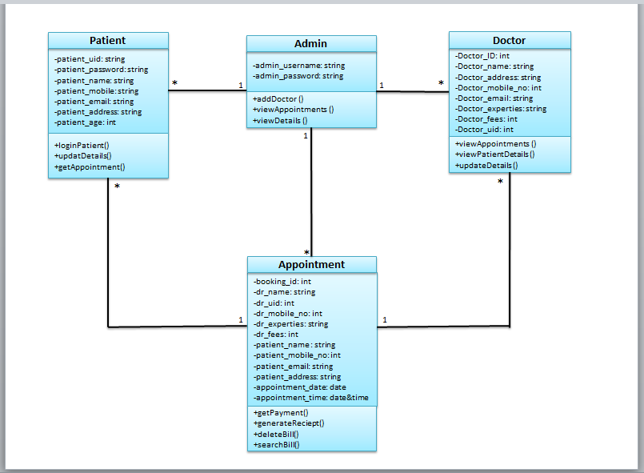

**Figure: Class Diagram**

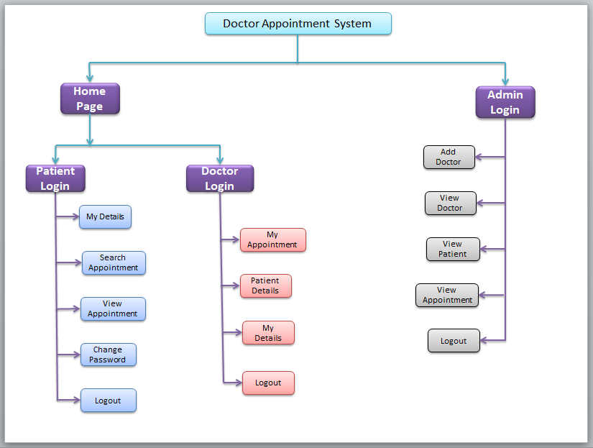

**Figure: Module Hierarchi Diagram**

## **2. Task and Activities Performed**

# Profile of Problems

In the present system all work is done on paper. It takes long process to get the appointments of the doctors. Patients need to go to the hospital and get the appointments of the doctors which will consume patient’s time and money

# Structure of the project

## Before Login

* + Login

## Register

## Medical Doctors

* + About Us

## Contact Us

* After Administrator Login

## Add Doctors

* + View Doctors

## View Patients

* + View Appointment
  + Logout

## After User Login

* + My Appointment

## Customers Details

## My Details

## Search Doctors

* + View Appointment

## Change Password

* + Logout

# Scope and Feasibility

## This activity is also known as the feasibility study. It begins with a request from the user for a new system. It involves the following:

* + - Identify the responsible user for a new system

## Clarify the user request

* + - Identify deficiencies in the current system

## Establish goals and objectives for the new system

* + - Determine the feasibility for the new system
    - Prepare a project charter that will be used to guide the remainder of the Project

# System Analysis

## It is a process of collecting and interpreting facts, identifying the problems, and decomposition of a system into its components.

System analysis is conducted for the purpose of studying a system or its parts in order to identify its objectives. It is a problem solving technique that improves the system and ensures that all the components of the system work efficiently to accomplish their purpose.

## The objective of the system analysis activity is to develop structured system specification for the proposed system. The structured system specification should describe what the proposed system would do; independent of the technology, which will be used to implement these requirements. The structured system specification will be used to implement these requirements.

The essential model may itself consist of multiple models, modeling different aspect of the system. The data flow diagrams may model the data and there relationships and the state transition diagram may model time dependent behavior of the system. The essential model thus consists of the following.

## Context diagram

* + - Leveled data flow diagrams

## Process specification for elementary bubbles

* + - Data dictionary for the flow and stores on the DFDs.

# System Design

## System design involves transformation of the user implementation model into software design. The design specification of the proposed system consists of the following:

# Implementation

This activity includes programming, testing and integration of modules into a progressively more complete system. Implementation is the process of collect all the required parts and assembles them into a major product.

# Test Generation

This activity generates a set of test data, which can be used to test the new system before accepting it. In the test generation phase all the parts are come which are to be tested to ensure that system does not produce any error. If there are some errors then we remove them and further it goes for accepting.

# Screen Shot

**Login Page:**

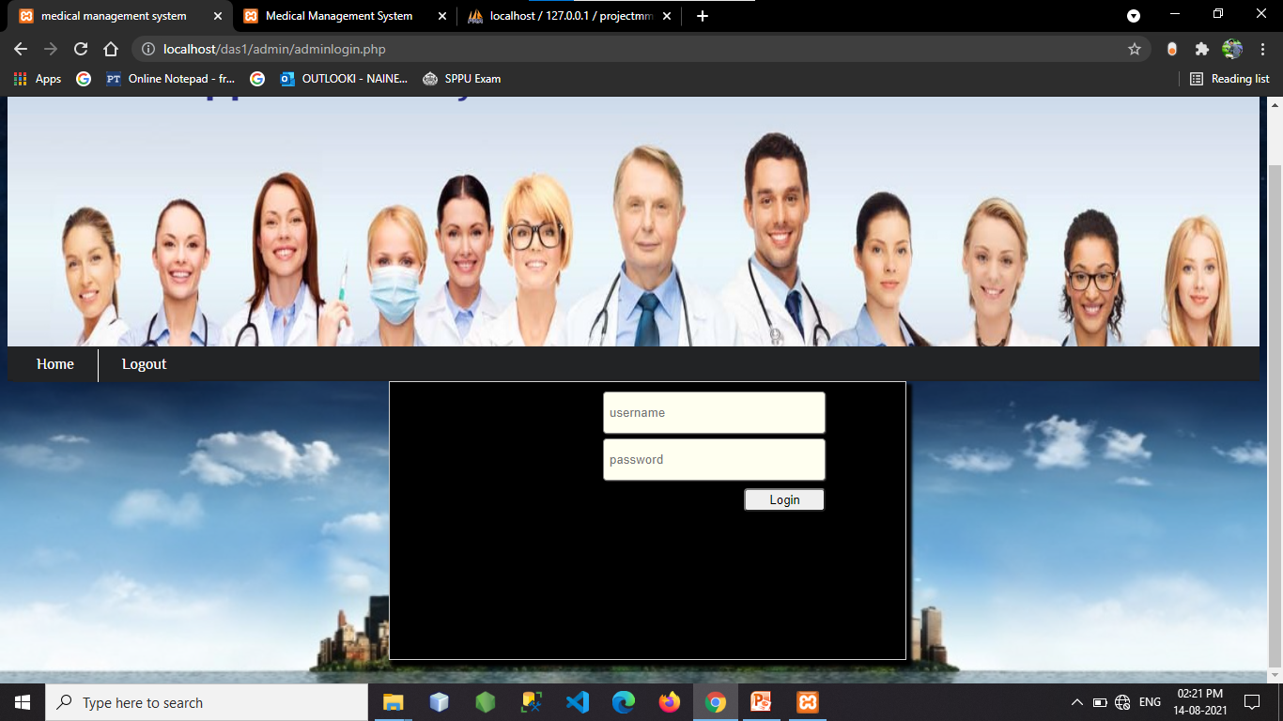

**Home Page:**

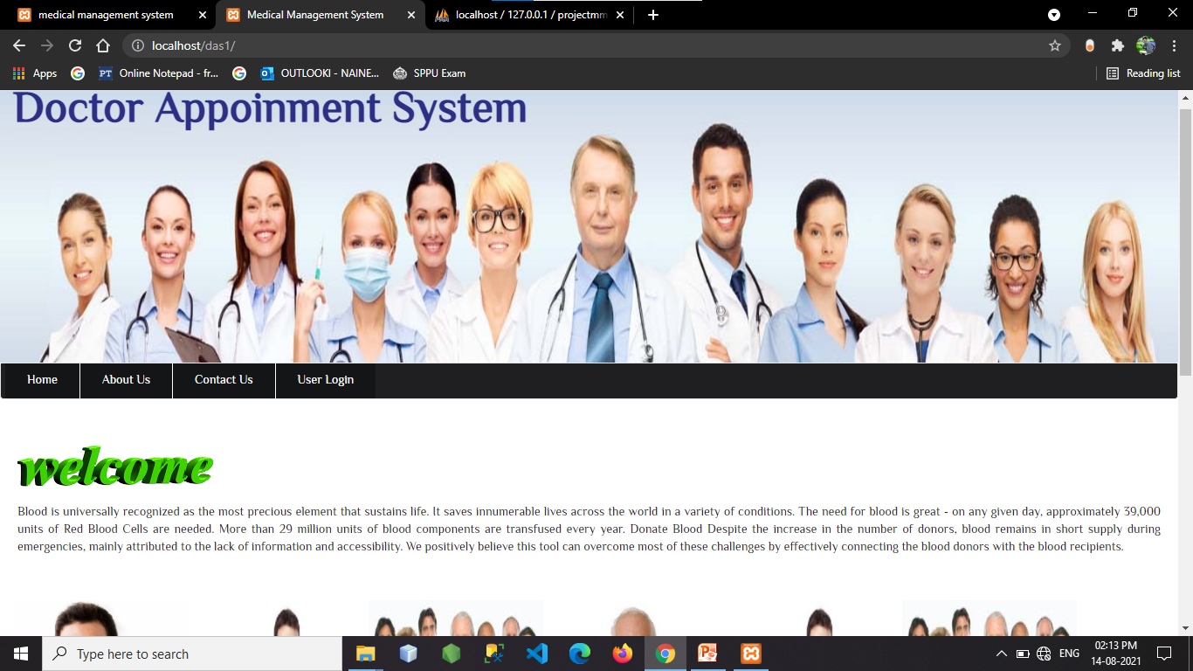

**Contact Page:**

